5L.1 Assignment(19CSE204)
Name = Ron Jacob Varghese
Class = S3,CSE-D
Roll No = AM.EN.U4CSE19346

Practise Lab Assignment-1
Code:
package net.codejava;
class Test {
// static variable
static int max = 10;
// non-static variable
int min = 5;
}
public class StaticDemo {
public static void main(String[] args) {
Test obj = new Test();
// access the non-static variable
System.out.println("min + 1 = " + (obj.min + 1));
// access the static variable
System.out.println("max + 1 = " + (Test.max + 1));
}
}

Output:
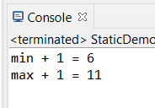

Observation:
In the above class a static variable is initialized to 10 and an instance variable is initiatlized to 5.An object of class test is created within the driver classs to access the instance variable min which then prints the min using the above mentioned object.Then the max is printed, as it is a static variable it can be accessed directly giving the output.
Practise Lab Assignment-2
Code:
package net.codejava;
class Box {
static int a = 42;
static int b = 99;
int c=50;
void computesum()
{ int sum=this.a+b;
System.out.println("Sum a+b = " + sum);
}
static void callme() {
System.out.println("a = " + a);
//System.out.println("c = " + c); //Error . Cannot make static reference to non Static Field
//computesum() //Error Cannot make a static reference to non static method
}
}
public class StaticDemo3 {
public static void main(String[] args) {
Box.callme();
System.out.println("b = " + Box.b);
//Box.computesum(); Error cannot make a static reference to non static method
Box obj=new Box();
obj.computesum();
}
}

Output:
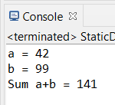
Observation:
Here the two static variables a,b are inititalized to 42,99 and another normal variable c is initialized to 50.It consists of an instance method computesum( that prints the sum of a and b),a static method callme ( which prints the static variable,this method can only be used for static variables and methods and hence some of the above lines are commented which will otherwise result in errors )
Practise Lab Assignment-3
Code:
package net.codejava;
public class StaticMain {
private static int numInstances = 0;
int a;
private static int getCount() {
return numInstances;
}
private static void addInstance() {
numInstances++;
}
StaticMain() {
StaticMain.addInstance();
}
public void doublea()
{
int doub=2*a;
System.out.println("double a="+doub);
System.out.println("Starting with " + getCount() + " instances");
}
public static void main(String[] args) {
System.out.println("Starting with " + getCount() + " instances");
for (int i = 0; i < 600; ++i) {
StaticMain obj=new StaticMain(); // Or new StaticMain() is enough as we dont need object
}
System.out.println("Created " + getCount() + " instances");
System.out.println("Starting with " + StaticMain.getCount() + " instances");
//doublea() //Error Cannot make static reference to non static method doublea
StaticMain obj2=new StaticMain();
obj2.doublea();
}
}

Output:
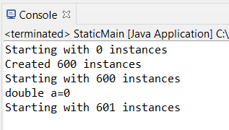
Observation:
Only a static method can access another static method or member otherwise it will result in an error.Only Instance methods can access both static methods and other instance methods .

